**JENKINS PLUG-INS**

Jenkins plugins are software components that extend Jenkins functionality. Plugins allow Jenkins to integrate with various tools, frameworks, platforms, and workflows, enabling customization of its core capabilities for continuous integration and continuous delivery (CI/CD).

**Purpose of Jenkins Plugins:**

* Add support for new tools, languages, and platforms.
* Automate tasks like building, testing, and deploying software.
* Enhance the user interface and user experience.
* Integrate Jenkins with external systems such as cloud providers, SCM systems, and notification tools.

**UPDATE PLUGINS**: Regularly update plugins to get the latest features and fixes.

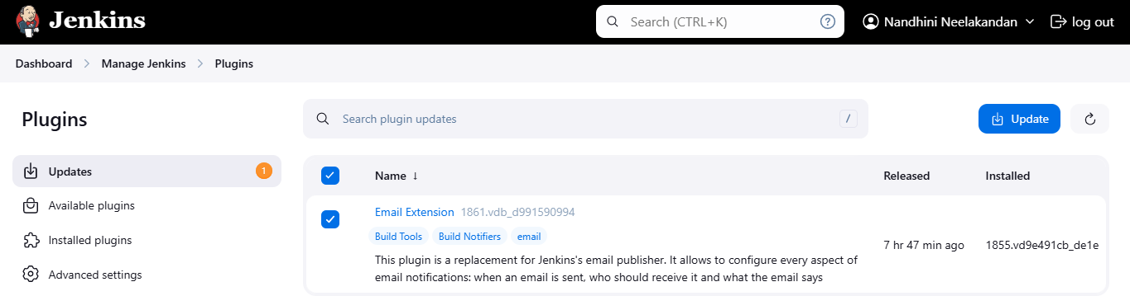

**AVAILABLE PLUGINS:** Plugins that are listed and can be installed from within the Jenkins user interface (UI) or the Jenkins Plugin Index. These plugins are typically categorized by their functionality.

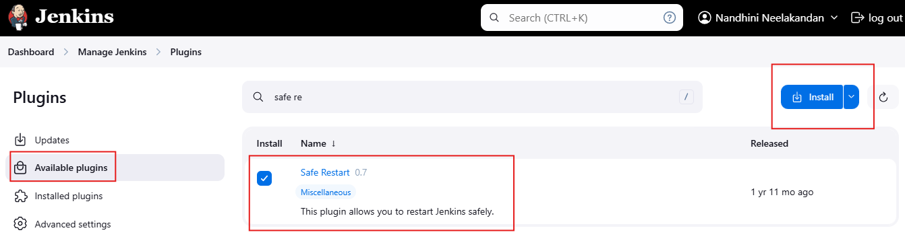

Select the required plugins, install it. After download got success restart the Jenkins.

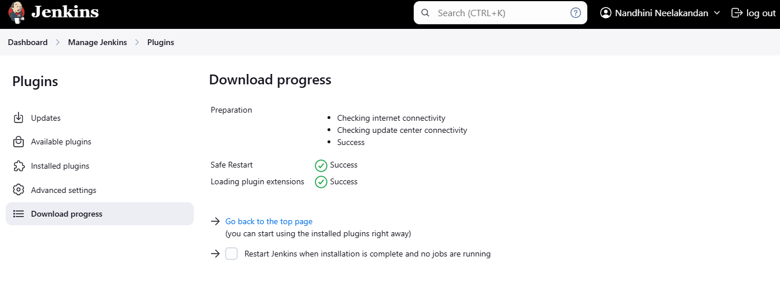

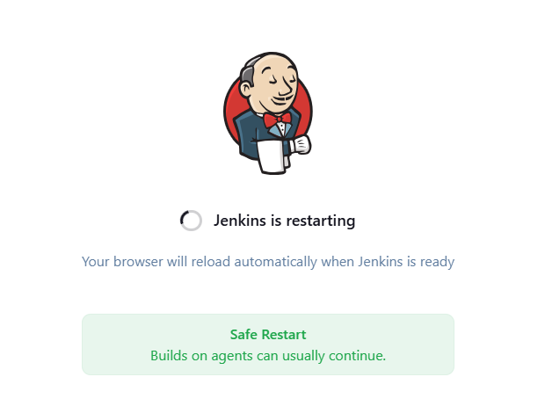

**INSTALLED PLUGINS:**

After installation and restarting the Jenkins we have to check where out plugin has been enabled in installed plugins.

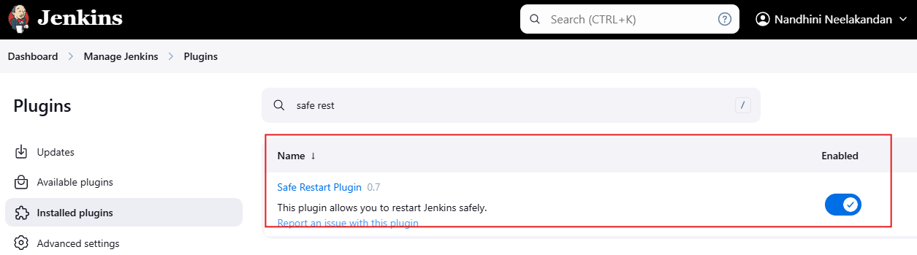

Safe restart plugin is available in Jenkins.

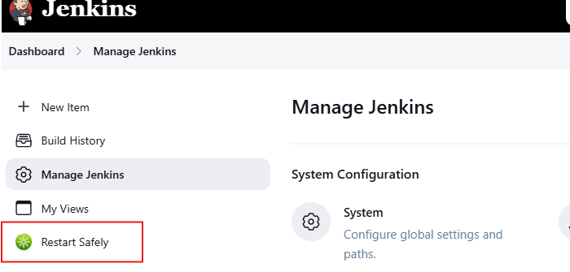

**EXTERNAL INTEGRATION:** External integration in Jenkins involves setting up connections between Jenkins and external services, applications, or infrastructure through APIs, plugins, webhooks, or custom scripts. The goal is to automate tasks, enhance collaboration, and manage the software delivery pipeline in a seamless and efficient manner.

**Step 1:** Manually Download and Install External Integration Plugins.

Download **Generic webhooks triggers.hpi** from web.

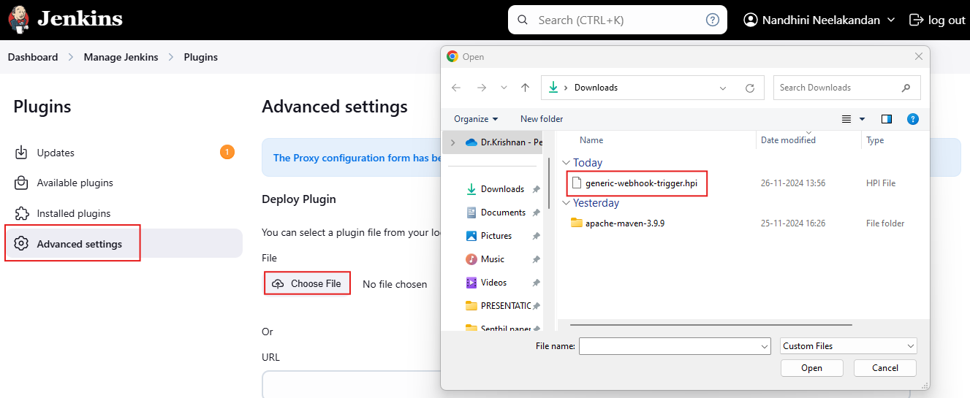

Deploying .hpi file from web.

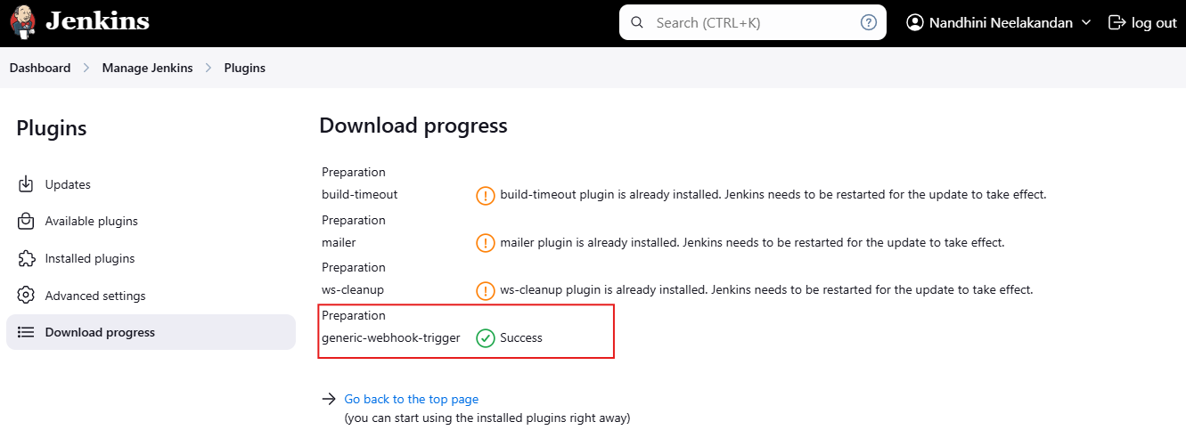

After download progress over, restart the plugin using SAFE RESTART Plugins.

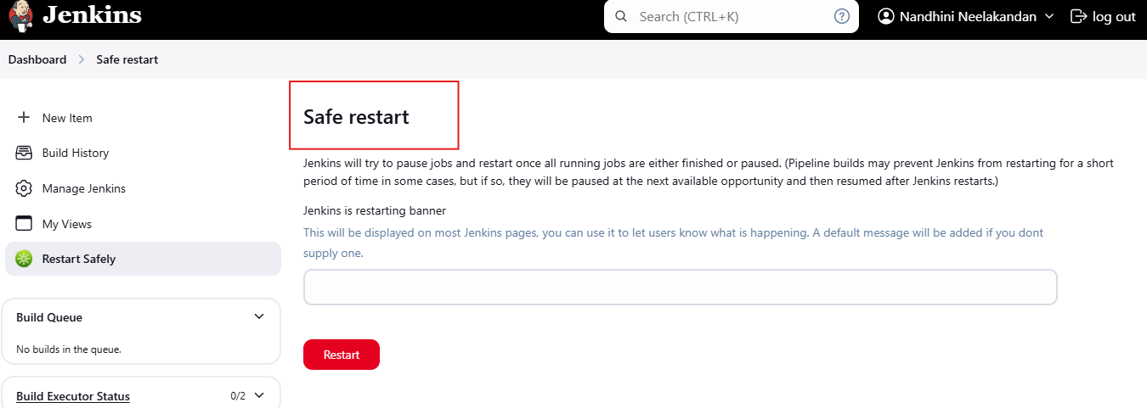

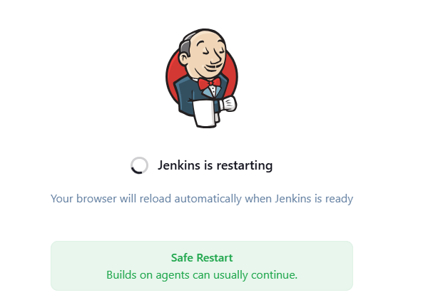

Finally check whether installed plugins has been enabled.

